Using Koolmoves with FrontPage

Embedding a SWF in a FrontPage document is simplicity itself.
- Create a Project folder, for example “c:\myproject”, and save your SWF inside that folder (there is no need to generate an html file as FrontPage uses the SWF file only.
- Open your FrontPage project and select the position where you wish to embed your SWF.

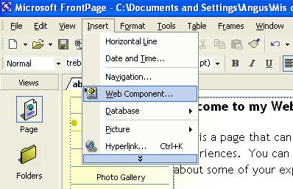

- Click “Insert” and then “Web Component” This will open another window.

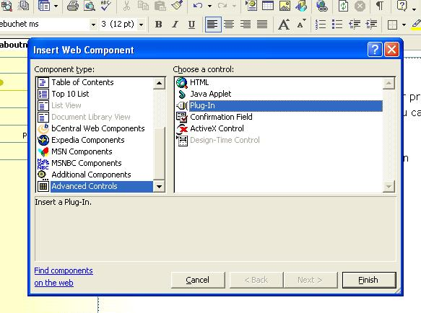

- Now select “Advanced Controls” and “Plug In” and click “Finish”

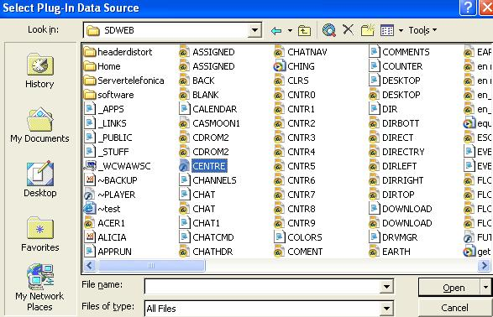

- This will open yet another window. Select your SWF file and click “Open” which will open yet another window.

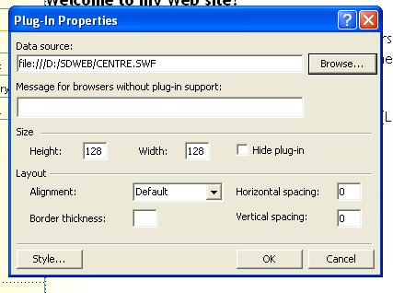

- Nearly done now. If the data is correct then hit “OK” and remember that you can use “height and width to scale your movie. It will scale automatically without having to alter any part of your original SWF file.

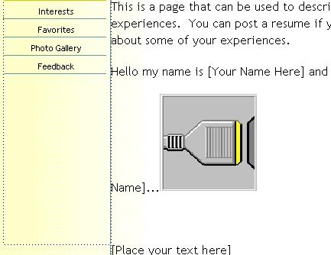

- Your page will now have an icon embedded in the position where you wish your movie to be and if you hit the “Preview button” then “Hey Presto”.

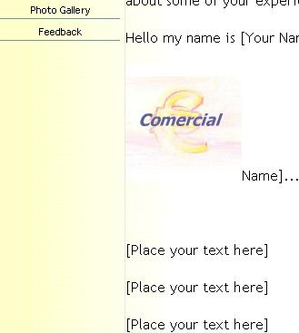

One Embedded Flash Movie.
You can now save your web page to the project folder and publish to your server or hosting service.
Enjoy.

